Name of Event: Climate Resilient Sustainable Models in Jharkhand
Date: 3rd Sep, 2022
Venue: Booty More, Ranchi
Ranchi, 3rd Sep, 2022: A two-day workshop on Climate Resilient Sustainable Models in Jharkhand was organized by Jharkhand CSO Forum and VB Net foundation in a local auditorium at Booty More Ranchi to brainstorm on the present situation of Agriculture in Jharkhand. Representatives from CSOs all across Jharkhand marked their presence to think and strategize the livelihood Models. Facilitating the session Mr. Vivek Roy from VB Net Foundation asserted that poor and marginal farmers are most vulnerable and they must be considered in the present times as priority. The main idea of the workshop was to present such models of development to Government which are beneficial for small farmers even in this time of crisis. Models on fishery, goatery, poultry, regenerative farming etc. Former principal scientist of ICAR Dr. Shivendra Kumar emphasized on the integrated model of livelihood for all sections of the society and to build upon the successful best practices piloted by NGOs in Jharkhand to promote the livelihood in drought like situation in Jharkhand.
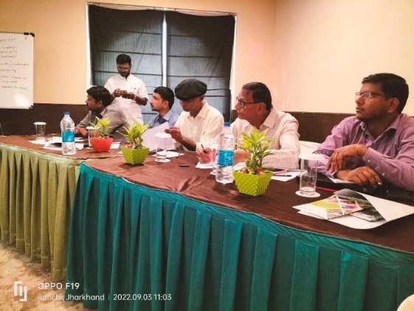
Addressing the issues Prof. Ramesh Sharan further added that covid has hit hard Jharkhand and as a result, education, health, and development here have taken a back seat. The skills of Jharkhand go outside as labour force as jobs are absent here.
The second day the CSO members presented prospective models of development in present context in Jharkhand. Funders from HDFC, Azim Premji Foundation also presented their perspective. They said that we should go for such models of development that are owned and nurtured by community Representative from Directorate of Agriculture appreciated the models and said that these models could be linked with Government schemes so that its efficiency is enhanced. Balram ji said that we need to have sustainable models of development which can be replicated over generations. The session ended finally with the compilation of few prospective models of development for Jharkhand and a working committee was constituted to carry this initiative forward. Arghya mukherjee and Shiv Shankar from Ajim premji foundation shared their views and offerings to the state in changing the current situation.
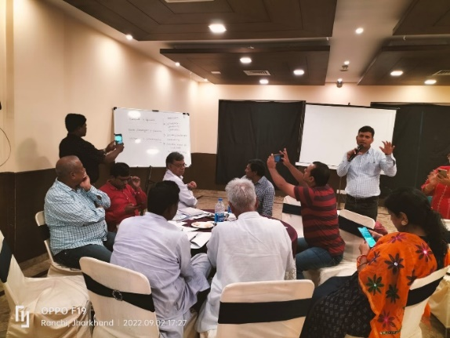
In this two-day workshop Vikas Gupta from HDFC- CSR, Gagan Meheta from WHH organization, Kaushik Roy from trickle up NGO marked their presence. From PRADAN Saurav Dutta and Sutar presented the model of comprehensive and sustainable livelihood with system change approach. Ashok Jha from Agriculture State Planning cell shared about the plan of the agriculture department and the role of relevant stakeholders to mitigate the drought like situation in Jharkhand. Prem Shankar focused on the role of the GO-NGO in mitigating the crisis and build the short term and long-term plan so that Jharkhand become prepared for any adverse situation in future. Members from VB Net Foundation made this event successful by putting in their consolidated efforts and Mr A N Pandey thanked all to make this event a success.

